TQ checklist Jira US ready check Process

Process map
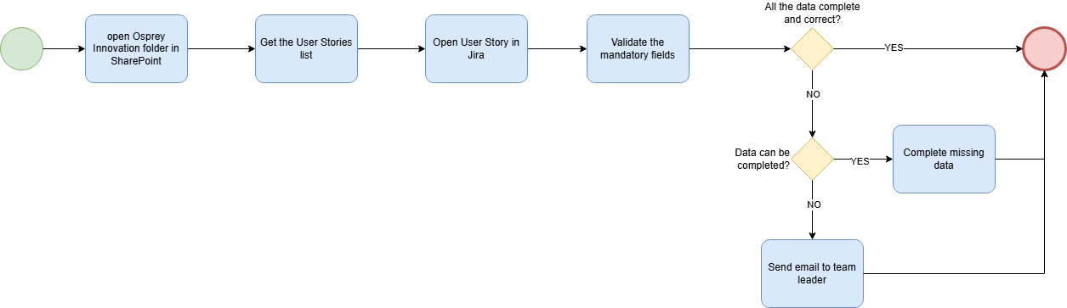

Step by step
Step | Screenshot
- In the SharePoint Project OSPREY - GMED 8.12 open “Documents”->”03_Streams”->”Innovation->”TQ Checklist Automation” | 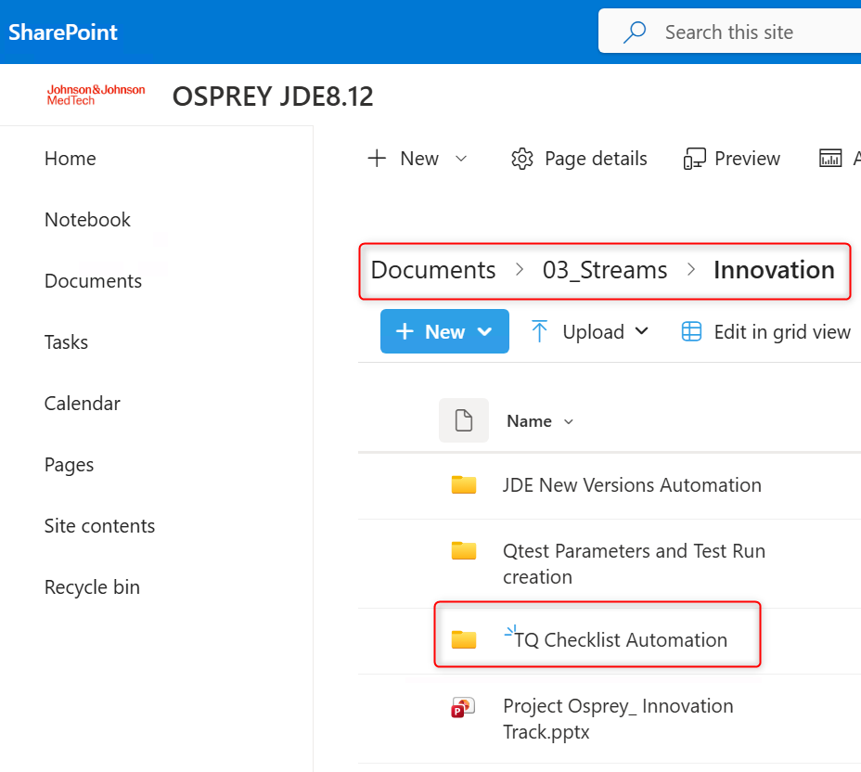
- Open the excel file “XYZ” that contains the list of User Stories needed to be checked
For each User story listed  - Open the Jira link for the User story  https://jira.jnj.com/browse/AASQ-NNNN  Where NNNN corresponds to the number of the User story | 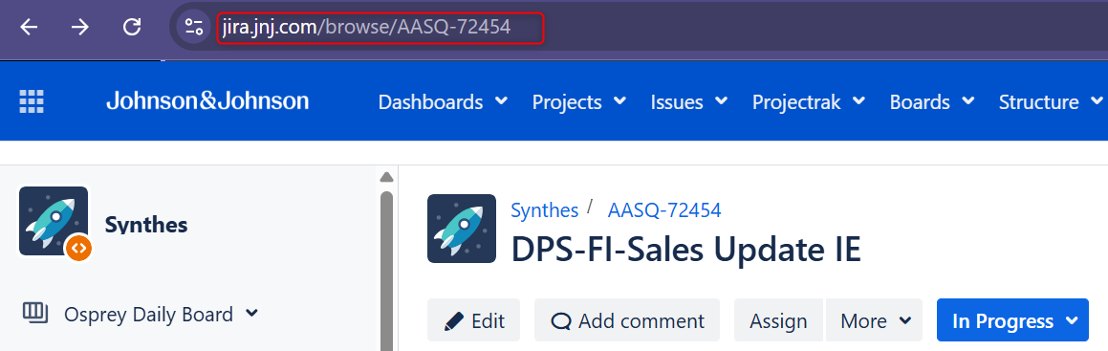
- Check the following fields as indicate:  - Affects version: It has to be filled with the value “Osprey_2026”. If it is empty complete it with the value mentioned.  - Fix version: It has to be filled with the value “Osprey_2026”. If it is empty complete it with the value mentioned.  - Component: It has to be filled with the value “JDE”. If it is empty or has another value, complete it with the value mentioned.  - Label: It has to be filled with the value “Osprey”. If it is empty or has another value, complete it with the value mentioned.  It has also need to be filled with the label according to the team related in the tab of the excel following the related logic. If the label corresponding to the team is not included, complete it according to the team rule  Team Jira Label  Finance FIN  Delivery  Loaner  - Acceptance Criteria: It has to contain three parts in the body of the message. “Given”, “When” and “Then” each follow by a text. If it is empty OR some of the three required parts are missing, send an email to the leader of the corresponding leader of the team, describing what is missing in the field for the User story evaluated.  Team Leader Email  Finance leader@its.jnj.com  Delivery  Loaner  - Compliance type: It has to be filled. If it is empty complete it with the value “GxP”. | 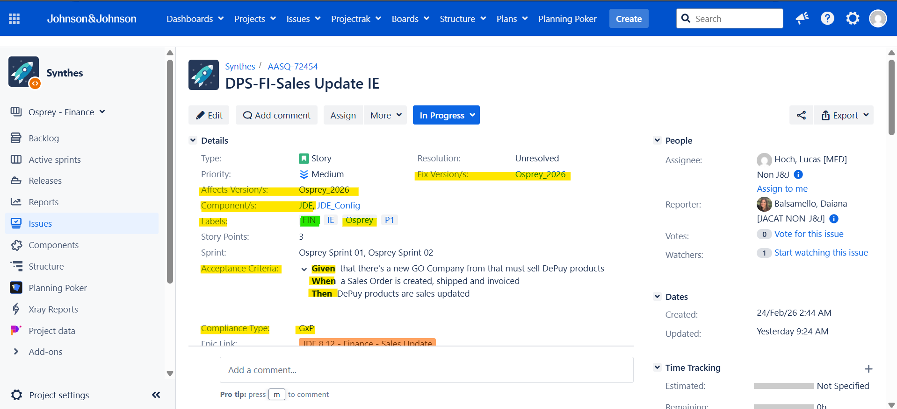  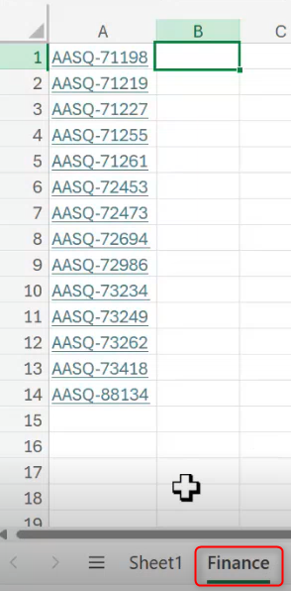
- EPIC Link: Check if in the details section of Jira exists the Epic Link field, if there is the field check that it is filled. If the field is not listed or if it is empty, send an email to the leader of the corresponding leader of the team, relating the missing information in the user story evaluated  - Team Name: Check if in the details section of Jira exists the Team Name field, if there is the field check that it is filled. If the field is not listed or if it is empty, complete with the value “EMEA_GMED_JDE8.12_JEDIKNIGHTS”  - Requirement ID: Check if in the details section of Jira exists the Requirement ID field, if there is the field check that it is filled. If the field is not listed or if it is empty, send an email to the leader of the corresponding leader of the team, relating the missing information in the user story evaluated  - Region: Check if in the details section of Jira exists the Region field, if there is the field check that it is filled. If the field is not listed or if it is empty, complete with the value “EMEA”  - Sector: Check if in the details section of Jira exists the Sector field, if there is the field check that it is filled. If the field is not listed or if it is empty, complete with the value “MedTech” | 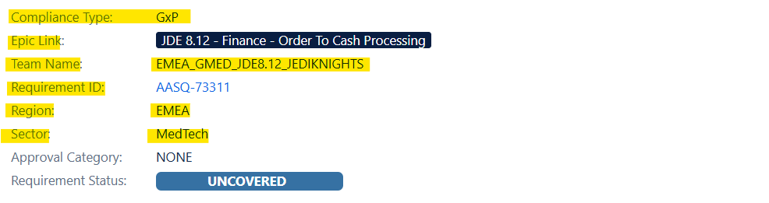
- Description: It has to contain three parts in the body of the message. “Who”, “What” and “Why” each follow by a text. If it is empty OR some of the three required parts are missing, send an email to the leader of the corresponding leader of the team, describing what is missing in the field for the User story evaluated.  - Issue Links: Check if there is an issue listed a “is a child task of” and that the issue listed is equal to the one in the requirements ID field. If there is any discrepancy with the issues in both fields, send an email to the leader of the corresponding leader of the team, describing the discrepancy in the two fields for the User story evaluated. | 